

**PES UNIVERSITY**

Department of Computer Science and Engineering

UE21CS351A: Database Management System

**Project Title:**

**Healthcare Management System**

**Team Members:**

Nagaraj Sori _ PES2UG21CS314

Nihal T M _ PES2UG21CS333

**Abstract**

The Healthcare Management System is a comprehensive software solution designed to streamline and enhance the operations of a healthcare facility, such as a hospital or clinic. In today's complex healthcare environment, efficient data management and patient care are essential. This system serves as a vital tool to optimize hospital processes, improve patient care, and facilitate the work of medical staff.

**Features:**

1. **Patient Management:** The system allows for the efficient management of patient information, including registration, medical history, and treatment plans.
2. **Doctor and Nurse Management:** Healthcare providers can manage doctor and nurse schedules, patient assignments, and medical staff information.
3. **Appointment Scheduling:** Patients can book appointments online, and the system assists in appointment scheduling, reducing waiting times and improving patient satisfaction.
4. **Prescriptions and Medical Records:** Doctors can create and manage prescriptions and medical records electronically, ensuring accurate and accessible patient information.
5. **Medical Departments:** The system categorizes medical services into departments such as General, Cardiology, Neurology, Dermatology, and more, streamlining healthcare specialization.
6. **Ward Management:** Hospitals can efficiently manage different types of wards, including General, Emergency, Operation Theatre, and ICU.
7. **Billing and Payment:** The system offers billing functionality for healthcare services, facilitating easy payment processing for patients.

**User Requirement Specifications**

**Functional Requirements:**

**1. Patient Management:**

* Allow hospital staff to register new patients with personal and medical information.
* Maintain and update patient records, including medical history and treatments.
* Enable medical staff to access patient information for diagnosis and treatment.

**2. Doctor and Nurse Management:**

* Provide a platform for the hospital administration to manage doctor and nurse schedules.
* Assign patients to doctors and nurses based on their expertise and availability.
* Maintain doctor and nurse profiles, including qualifications and responsibilities.

**3. Appointment Scheduling:**

* Allow patients to schedule appointments online or through the system.
* Ensure that appointments do not conflict with doctor and nurse schedules.
* Send appointment reminders to patients via email or SMS.

**4. Prescriptions and Medical Records:**

* Allow doctors to create, update, and manage electronic prescriptions and medical records.
* Ensure the security and privacy of patient records, following healthcare data protection regulations.

**5. Medical Departments:**

* Categorize healthcare services into various departments (e.g., Cardiology, Neurology).
* Assist patients in selecting the appropriate department for their medical needs.

**6. Ward Management:**

* Enable the hospital staff to manage different types of wards.
* Assign patients to specific wards based on their medical condition and treatment requirements.

**7. Billing and Payment:**

* Generate bills for healthcare services provided to patients.
* Allow patients to make payments online or at the hospital.
* Maintain a record of payments and outstanding balances.

**Non-Functional Requirements:**

**1. Technology Stack:**

* Frontend: HTML, CSS, JavaScript, ReactJS (for a responsive and interactive UI).
* Backend: Node.js (for server-side logic).
* Database: MySQL (for data storage and retrieval).

**2. Performance:**

* Ensure the system responds quickly to user interactions, providing a seamless experience.
* Implement caching mechanisms to improve performance.

**3. Security:**

* Implement robust security measures to protect patient data and comply with healthcare data privacy regulations.
* Use encryption for data transmission and storage.

**4. Scalability:**

* Design the system to accommodate future growth in terms of patients, doctors, and medical facilities.

**5. Usability:**

* Develop an intuitive and user-friendly interface for both hospital staff and patients.
* Conduct usability testing to ensure an efficient user experience.

**6. Data Backup and Recovery:**

* Regularly back up patient data to prevent data loss.
* Establish a data recovery plan to restore data in case of unexpected incidents.

**7. Integration:**

* Ensure the system can integrate with external systems or APIs, such as insurance providers or laboratory services.

**8. Compliance:**

* Ensure compliance with healthcare regulations and standards, such as HIPAA, to protect patient privacy and data security.

**Relation Schema:**

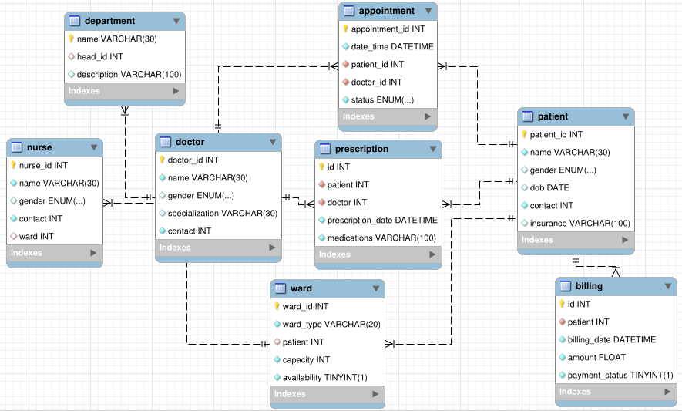

**ER Diagram:**

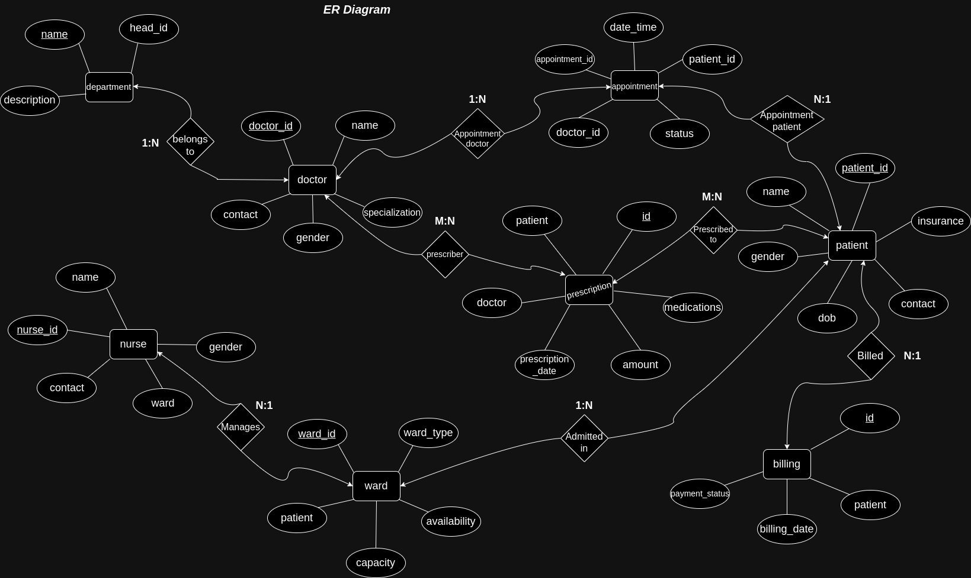

**Conclusion:**

This Healthcare Management System aims to provide hospitals and healthcare facilities with a powerful tool to streamline their operations, improve patient care, and ensure data security. It leverages modern web development technologies to deliver a responsive and user-friendly experience for both healthcare providers and patients.